AVP Report Factory Framework Quickstart Guide

Developed by IBM Bigfix AVP

September 28, 2016

### Overview

The report factory framework is designed to provide a framework for quickly enabling similar types of reports. This framework is not officially supported, however has been developed and maintained by the IBM Bigfix Team. The framework also allows advanced customization within an external loader script. Which allows organizations to creae reports that leverage the framwewrok as well, and inherit the additional functionality.

### UI Design

The UI is meant to provide a simple interface allowing users to search for reports that are loaded at run time. The user is presented a dropdow on the main page, the dropdown is loaded with a series of report definitions availible based upon the enviornment and loaded sites. This report framework is designed for use with Chrome, firefox , and other webkit based browsers. This framework does not perform well on IE

### Basic Usage

Select a report from the drop down menu. With live search, quickly find reports by category or keyword.

Examples:

* Search “Operators” to view reports related to Bigfix operators.
* Search “SCM” to view reports related to secure configuration checklist - DISA STIG, USGCB.
* Search “Patch” to view reports related to patching - Windows, Unix, Updates for Windows Applications.
* Search “Adobe” to see reports related to Adobe applications.
* Search “Bigfix Content” to review reports relative to Bigfix Content.
* Search “Scorecard” to review the beta AVP score card, a analysis of system security and compliance

Screenshots below demonstrate the search functionality

|  |
| --- |
|  |
| Here we are searching for content reports. The report live search reflects the availible reports. |
|  |
| Here we are searching for bulletin. The report live search reflects the availible bulletin reports. |

Once a report has loaded, you can view information for the related fixlets such as source severity, associated CVEs, source release date, number of applicable computers and more. Based upon what report has been selected the columns availible will change to reflect more pertinant information.

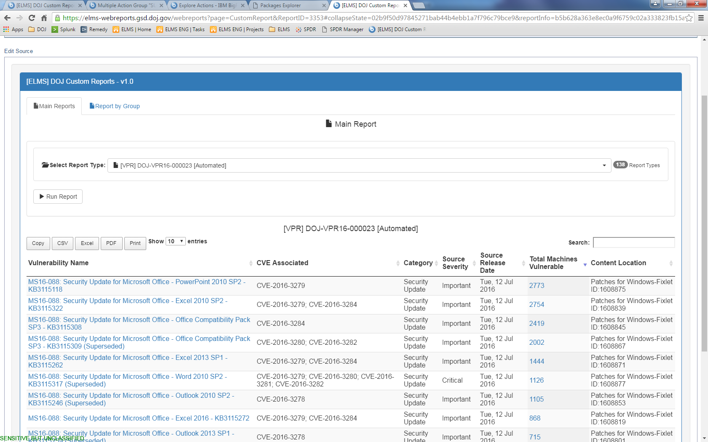

By selecting a specfic fixlet, a sub-report will open in the **Drilldowns** tab. The sub-report allows you to view the full fixlet description and details as well as the numebr of open and taken actions for that fixlet. The full fixlet relevance is also displayed.

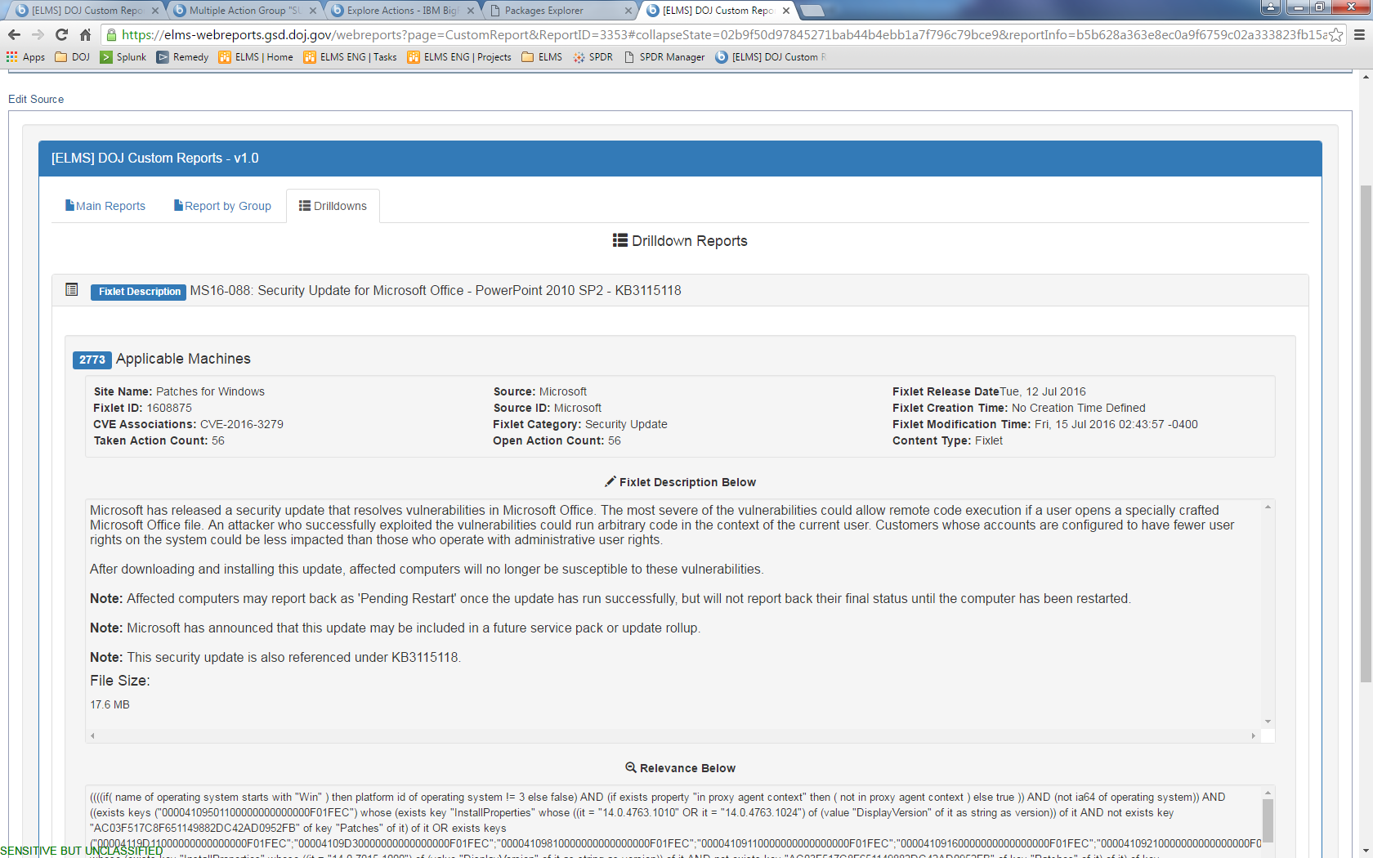

You can go back to the main report results by selecting the **Main Reports** tab. Sub-reports that load into the Drilldownstab remain accessilbe without having to reload the report. You can navigate between the different tabs or run a new report from the drop down menu without losing sub-reports.

By clicking on the number of applicable computers for a fixlet, you can access a drilldown report of the affected systems.

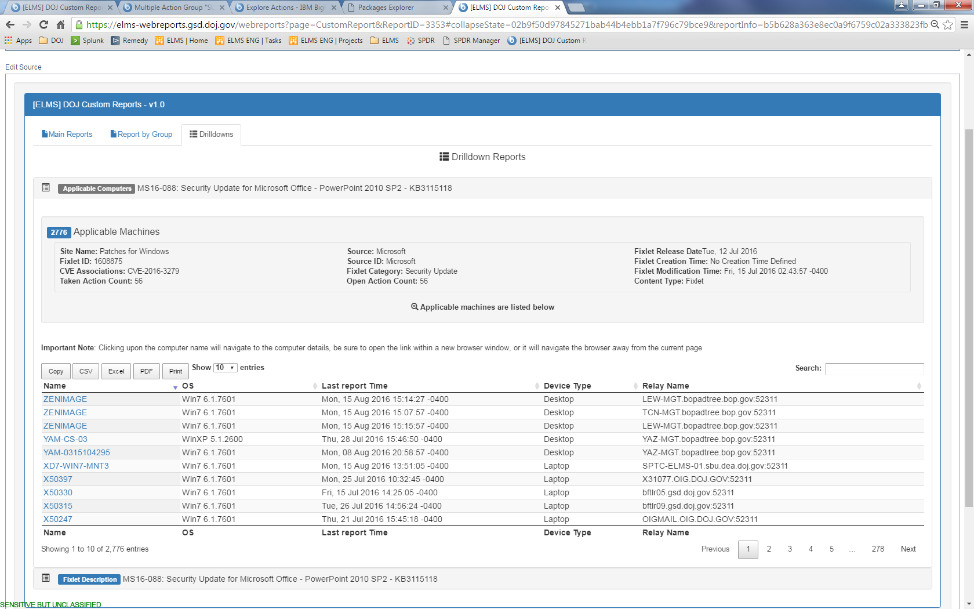

The **Report by Group** tab allows you to run the main report against multiple computer groups to see the the number of applicable computers for a fixlet in each selected group. Choose up to 10 groups and select Run Report.

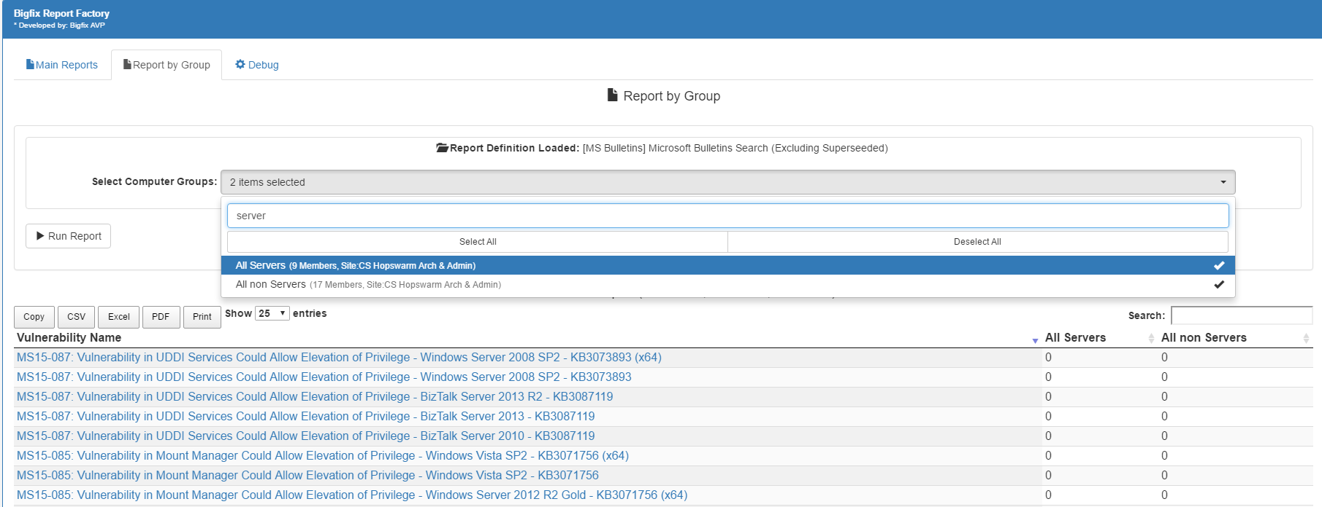

* Webkit browsers supported (Google Chrome, Mozilla Firefox).
* Export to PDF function may be blocked by the security settings of your system.

**Tip:** External filters can be used to filter the report list and results by a sepcific criteria. For example, to only see reports for a particular group of computers or operating system, you can define a filter before selecting a report. Applying a filter will cause the report to reload.

